**PROJECT REPORT**

**ON**

**HARDWARE SELECTION AND DESIGN**

**Table of Contents:**

**1. Introduction**

**2. Fundamentals of Hardware Design**

**3. About Hardware**

**4. ECUs, Sensors, and Actuators**

**5. System Architecture and Network Topology**

**6. Communication Protocols and Component**

**7. Wiring Harness and Connector Plan**

**What Is Hardware?**

At its core, hardware refers to the physical components that make up a system. In the context of vehicles, it encompasses all the tangible parts and devices integrated into the vehicle's design. These components can range from mechanical parts like the engine and transmission to electronic systems like sensors and onboard computers.

**History of Hardware in Electric Vehicles System**

• **Late 1800s:** First electric vehicles by inventors like Ányos Jedlik and Robert Anderson.

• **1890:** William Morrison built the first practical electric vehicle.

• **Early 1900s:** EVs were popular but declined due to cheaper gasoline cars.

• **Mid-20th Century:** EVs used in niche applications like golf carts.

• **21st Century:** Revival with advancements in battery and motor technology.

• **Modern EVs:** Mass-market models by Tesla and Nissan improved range and performance.

• **Global Adoption:** Rapid increase in EV sales worldwide.

**Hardware Architecture**

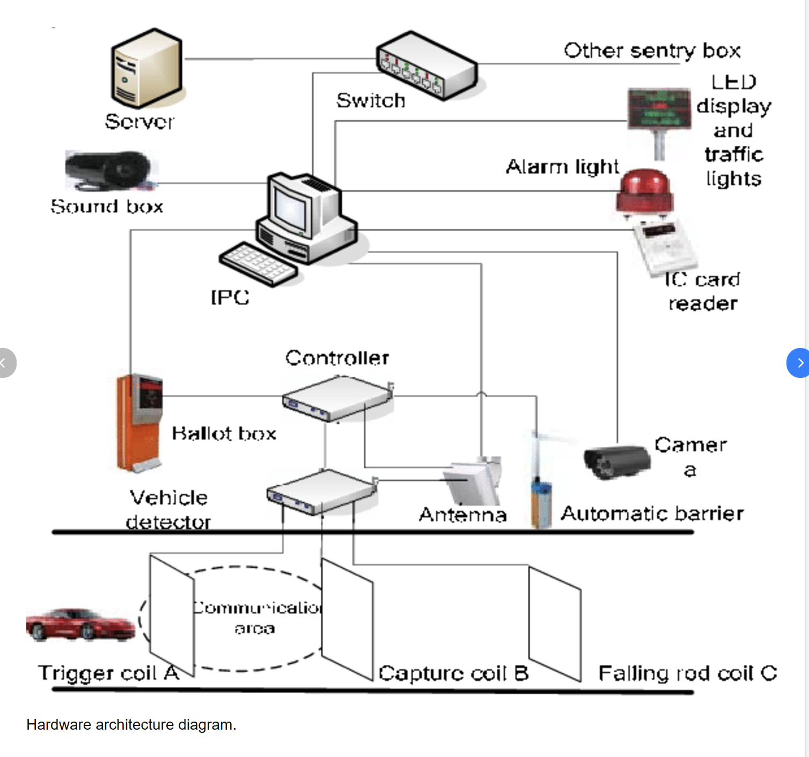

**How Hardware System is used in EVs**

Electric vehicles (EVs) rely on several key hardware systems to function efficiently. Here are some of the main components:

1. **Battery Pack:** Stores electrical energy, typically using lithium-ion batteries.
2. **Electric Motor:** Converts electrical energy into mechanical energy to drive the wheels.
3. **Power Electronics Controller:** Manages the flow of electrical energy from the battery to the electric motor, controlling speed and torque.
4. **Onboard Charger:** Converts AC power from the grid to DC power to charge the battery.
5. **DC-DC Converter:** Steps down the high-voltage DC from the battery to lower voltages needed for vehicle electronics.
6. **Battery Management System (BMS):** Monitors and manages the battery pack, ensuring safety and efficiency.
7. **Thermal Management System:** Maintains optimal operating temperatures for the battery and other components.
8. **Transmission:** Transfers power from the electric motor to the wheels.
9. **Vehicle Control Unit (VCU):** Acts as the brain of the vehicle, coordinating all electronic components.

**How Hardware System works in ECUs, Sensors, and Actuators**

Electronic Control Units (ECUs), sensors, and actuators are integral parts of modern vehicle systems, working together to ensure optimal performance and safety. Here's a breakdown of how they function:

**Electronic Control Units (ECUs)**

ECUs are essentially the "brains" of the vehicle. They receive data from various sensors, process this information, and then send commands to actuators to control different vehicle functions2. ECUs are responsible for managing systems like the engine, transmission, brakes, and more.

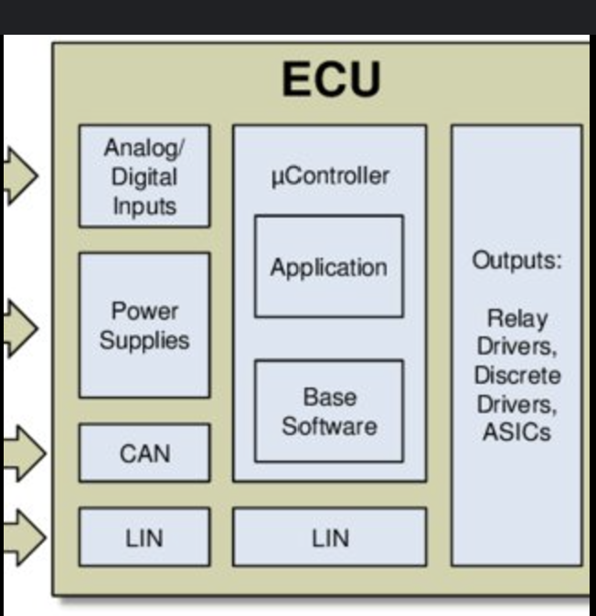

### History of ECUs

The earliest ECUs were mechanical-hydraulic units used in aircraft engines in the late 1930s. The first automotive ECUs appeared in the 1970s, with the Ford EEC system in 19755. Over the years, ECUs have become more sophisticated, incorporating digital electronics and advanced software to manage various vehicle systems.

• **Sensors:**

* **Ultrasonic Sensors:** There are four front sensors and four rear sensors. These detect obstacles and measure distances, which is crucial for functions like parking assistance.
* **Speed Sensor:** This sensor monitors the speed during parking to ensure it remains below a safe threshold.

• **Input Controls:**

* **SAPS ON/OFF:** A switch to turn the system on or off.
* **Forward/Reverse:** Controls the direction of vehicle movement.

• **ECU (Electronic Control Unit):**

* The central processor of the system. It receives signals from sensors and input controls.
* It processes this data to generate appropriate control commands.

• **Output Controls:**

* **Engine Switch:** Manages the engine’s state.
* **Gear Shift Actuation:** Handles gear shifting.
* **Brake Actuation:** Controls the braking system.
* **Clutch Actuation:** Manages the clutch mechanism.

**How ECUs are used in Vehicles**

ECUs are essentially the "brains" of a vehicle, managing and controlling various systems to ensure optimal performance, efficiency, and safety. Here are some common types of ECUs in vehicles:

* **Engine Control Module (ECM):** Manages engine performance by regulating fuel injection, ignition timing, and other parameters.
* **Transmission Control Module (TCM):** Controls the operation of the transmission, ensuring smooth gear shifts.
* **Brake Control Module (BCM):** Manages the braking system, including anti-lock braking (ABS) and stability control.
* **Body Control Module (BCM):** Controls various electrical systems such as lighting, door locks, and windows.
* **Suspension Control Module (SCM):** Manages the suspension system to provide a smooth ride.
* **Climate Control Unit (CCU):** Manages the heating, ventilation, and air conditioning (HVAC) system.

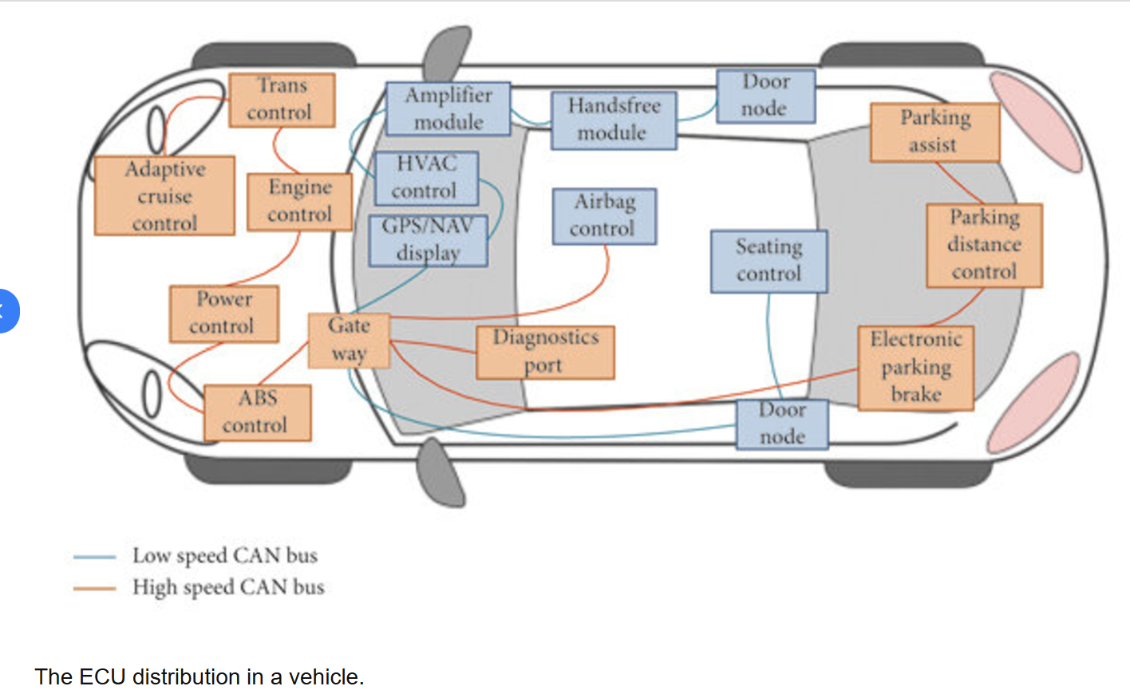

**TYPES OF ECUs**

There are several types of ECUs, each with specific functions in a vehicle's system. Here's a rundown of the most common types:

**Engine and Powertrain ECUs**

1. **Engine Control Module (ECM):** Manages the engine's operations, including fuel injection, ignition timing, and emissions control.
2. **Transmission Control Module (TCM):** Controls the automatic transmission's shifting and torque converter.

**Chassis ECUs**

1. **Brake Control Module (BCM):** Manages the anti-lock braking system (ABS) and electronic stability control (ESC).
2. **Suspension Control Module (SCM):** Regulates the vehicle's suspension settings for optimal ride comfort and handling.

**Body and Comfort ECUs**

1. **Body Control Module (BCM):** Manages various body functions like lighting, door locks, and windows.
2. **Climate Control Module (CCM):** Controls the heating, ventilation, and air conditioning (HVAC) system.

**Driver Assistance ECUs**

1. **Adaptive Cruise Control (ACC):** Maintains a set speed and distance from the vehicle ahead.
2. **Lane Keeping Assist (LKA):** Helps keep the vehicle centered in its lane.
3. **Parking Assist Module:** Assists with parking by using ultrasonic sensors to detect obstacles.

**Infotainment and Connectivity ECUs**

1. **Infotainment Control Module (ICM):** Manages the vehicle's entertainment system, including audio, video, and navigation.
2. **Telematics Control Unit (TCU):** Handles communication and data exchange with external systems like navigation services, emergency response, and remote diagnostics.

**Safety ECUs**

1. **Airbag Control Module (ACM):** Controls the deployment of airbags in the event of a collision.
2. **Tire Pressure Monitoring System (TPMS):** Monitors tire pressure and alerts the driver if it falls below a safe level.

**Hybrid and Electric Vehicle ECUs**

1. **Battery Management System (BMS):** Manages the charging and discharging of the battery in hybrid and electric vehicles.
2. **Inverter Control Module:** Controls the power conversion between the battery and the electric motor.

**Use Cases of ECUs in EVs**

Electronic Control Units (ECUs) in electric vehicles (EVs) play a crucial role in managing various systems to ensure efficient, safe, and comfortable operation. Here are some key use cases:

### ****Battery Management****

* **Battery Management System (BMS):** ECUs monitor and control the battery's state of charge (SOC), state of health (SOH), temperature, voltage, and current to optimize performance and extend battery life.

### ****Motor Control****

* **Motor Control Unit (MCU):** ECUs manage the electric motor's speed, torque, and efficiency, ensuring smooth and responsive acceleration.

### ****Regenerative Braking****

* **Regenerative Braking System:** ECUs control the regenerative braking process, converting kinetic energy back into stored electrical energy in the battery during braking.

### ****Thermal Management****

* **Thermal Management System:** ECUs regulate the cooling and heating of the battery, motor, and other components to maintain optimal operating temperatures.

### ****Safety Systems****

* **Automatic Emergency Braking (AEB):** ECUs process data from sensors to detect potential collisions and automatically apply the brakes if necessary.
* **Traction Control System (TCS):** ECUs manage the distribution of power to the wheels to prevent wheel slip and maintain vehicle stability.

### ****Driver Assistance Systems****

* **Adaptive Cruise Control (ACC):** ECUs maintain a set speed and distance from the vehicle ahead, adjusting speed as needed.
* **Lane Keeping Assist (LKA):** ECUs help keep the vehicle centered in its lane by making minor steering adjustments.

### ****Infotainment and Connectivity****

* **Infotainment System:** ECUs manage the vehicle's entertainment, navigation, and communication systems, providing a seamless user experience.
* **Vehicle-to-Everything (V2X) Communication:** ECUs facilitate communication with other vehicles, infrastructure, and devices to enhance safety and traffic management.

### ****Energy Efficiency****

* **Energy Management System:** ECUs optimize the use of energy, reducing waste and improving the vehicle's range.

### ****Comfort and Convenience****

* **Climate Control:** ECUs manage the heating, ventilation, and air conditioning (HVAC) system to maintain a comfortable cabin environment.
* **Keyless Entry and Start:** ECUs handle the keyless entry and start systems, providing convenience and security.

### ****Diagnostics and Maintenance****

* **On-Board Diagnostics (OBD):** ECUs enable OBD systems to monitor vehicle health, diagnose issues, and provide maintenance alerts.

These use cases highlight the versatility and importance of ECUs in electric vehicles.

**Advantages of ECUs in EVs**

• **Performance Optimization:** Better fuel economy and engine performance.

• **Safety Enhancements:** Enables advanced driver assistance and real-time monitoring.

• **Environmental Benefits:** Reduces emissions and supports regenerative braking.

• **Customization and Flexibility:** Programmable and user-configurable settings.

• **Comfort and Convenience:** Manages climate control and automated features.

### ****Disadvantages of ECUs in EVs****

* **Complexity:** Harder to diagnose and repair.
* **Cost:** Expensive to develop and maintain.
* **Dependence on Electronics:** Vulnerability to electronic failures.
* **Software Issues:** Potential for bugs and glitches.

### ****Notable Features:****

* Real-time data processing, communication networks, adaptive learning, remote diagnostics, and energy management.

**What is Sensors?**

In electric vehicles (EVs), sensors play a crucial role in monitoring and managing various systems to ensure efficient and safe operation.

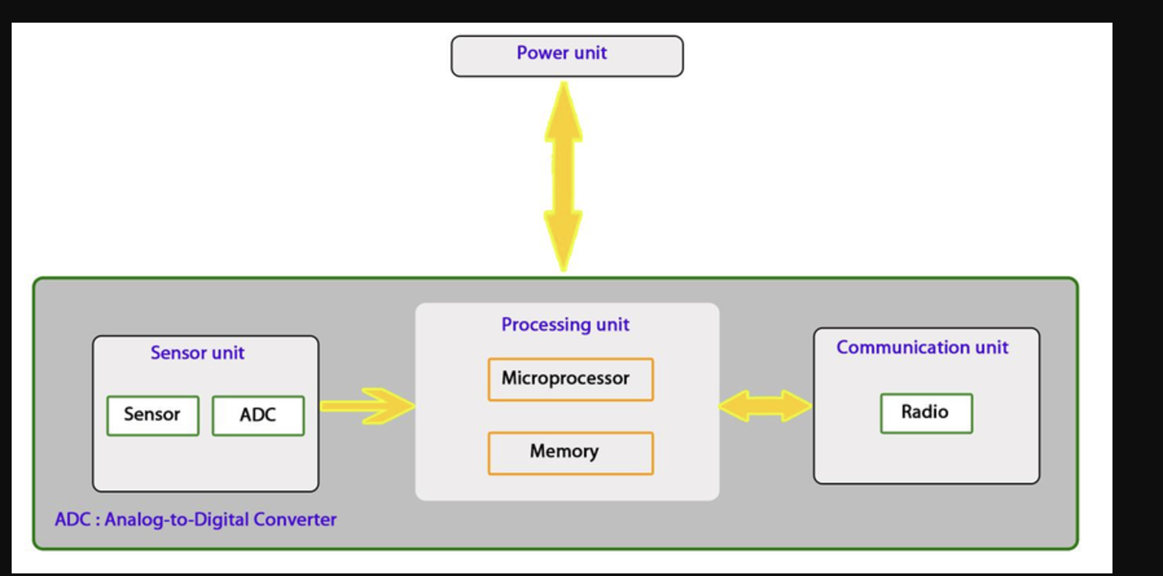

**History of Sensors**

The history of sensors dates back thousands of years, starting with simple devices like the **sundial**, which measured time by the position of the sun, and the **mercury-in-glass thermometer**, which changed size in response to temperature changes.

• **Early 1800s:** Wilhelm von Siemens developed a temperature sensor based on the electrical resistance of materials.

• **1883:** Warren Johnson invented the first modern electric thermostat.

• **Early 1950s:** Samuel Bagno invented the first motion sensor using ultrasonic frequencies and the Doppler effect for alarm systems.

• **Late 20th Century:** Advances in materials science and silicon processing led to the development of a wide range of high-performance sensors.

• **Modern Era:** Sensors have become integral to various applications, including automotive, consumer electronics, industrial systems, medical devices, and environmental monitoring.

**Use Cases of Sensors IN EVs**

#### ****1. Battery Management****

* **Battery Management System (BMS) Sensors:** Monitor the state of charge (SOC), state of health (SOH), temperature, voltage, and current of the battery pack to ensure optimal performance and longevity.

#### ****2. Thermal Management****

* **Temperature Sensors:** Measure the temperature of the battery, motor, and other critical components to prevent overheating and manage cooling systems efficiently.

#### ****3. Motor Control****

* **Position Sensors:** Determine the position of the motor's rotor for precise control of motor speed and torque.
* **Speed Sensors:** Monitor the speed of the vehicle and the motor's rotation to ensure smooth operation.

#### ****4. Regenerative Braking****

* **Accelerometers:** Measure deceleration forces to optimize the regenerative braking system, converting kinetic energy back into electrical energy for storage in the battery.

#### ****5. Safety and Driver Assistance****

* **Proximity Sensors:** Detect obstacles and assist in parking, collision avoidance, and other driver assistance features.
* **Cameras and Radar Sensors:** Enable advanced driver assistance systems (ADAS) such as lane-keeping assist, adaptive cruise control, and automatic emergency braking.

#### ****6. Energy Efficiency****

* **Current Sensors:** Monitor the flow of current to and from the battery and motor to optimize energy use and extend the vehicle's range.
* **Voltage Sensors:** Measure voltage levels to ensure the efficient operation of electrical systems.

#### ****7. Climate Control****

* **Humidity and Temperature Sensors:** Manage the vehicle's heating, ventilation, and air conditioning (HVAC) system to maintain a comfortable cabin environment.

#### ****8. Infotainment and Connectivity****

* **Light Sensors:** Adjust the brightness of displays based on ambient light conditions.
* **Touch Sensors:** Enable touch-screen controls for navigation, entertainment, and other functions.

#### ****9. Diagnostics and Maintenance****

* **Oxygen Sensors:** Monitor exhaust gases in hybrid vehicles to optimize combustion and reduce emissions.
* **Knock Sensors:** Detect engine knock in hybrid vehicles and adjust ignition timing to prevent damage.

**Types of Sensors in EVs**

• **Battery Management System (BMS) Sensors:** Monitor battery health, state of charge (SOC), state of health (SOH), temperature, voltage, and current.

• **Temperature Sensors:** Measure the temperature of the battery, motor, and other critical components to prevent overheating.

• **Current Sensors:** Monitor the current flow to and from the battery and motor.

• **Voltage Sensors:** Measure the voltage levels of the battery and other electrical systems.

• **Speed Sensors:** Detect the speed of the vehicle and the rotation of the motor.

• **Position Sensors:** Determine the position of the motor's rotor to control its movement accurately.

• **Accelerometers:** Measure the acceleration forces to assist in stability control and regenerative braking.

• **Proximity Sensors:** Detect obstacles and assist in parking and collision avoidance.

• **Oxygen Sensors:** Monitor exhaust gases in hybrid vehicles to optimize combustion and reduce emissions.

• **Knock Sensors:** Detect engine knock in hybrid vehicles to adjust the ignition timing and prevent damage.

**Advantages of Sensors in EVs**

• **Enhanced Safety:** Early detection of issues and conditions.

• **Improved Efficiency:** Optimizing performance and energy use.

• **Convenience:** Automating and simplifying tasks.

• **Data Collection:** Providing valuable insights and analytics.

• **Customization:** Tailoring systems to specific needs and preferences.

**Disadvantages of Sensors in EVs**

• **Cost:** High-quality sensors can be expensive.

• **Complexity:** Integrating multiple sensors can be challenging.

• **Calibration:** Requires regular calibration for accuracy.

• **Power Consumption:** Some sensors consume significant power.

• **Vulnerability:** Susceptible to damage and environmental conditions.

### ****Features and Benefits of Sensors in EVs:****

* **Accuracy and Precision:** Sensors provide precise measurements essential for optimal performance.
* **Real-time Monitoring:** Continuous data collection helps in real-time adjustments for safety and efficiency.
* **Improved Efficiency:** Optimizes energy use, extending the vehicle's range.
* **Enhanced Safety:** Detects potential hazards and supports advanced safety features.
* **Comfort and Convenience:** Manages climate control and other comfort features for an improved driving experience.

**What is Actuator?**

An **actuator** is a device that converts electrical signals into mechanical motion. In electric vehicles (EVs), actuators play a crucial role in controlling various systems, such as steering, braking, and throttle.

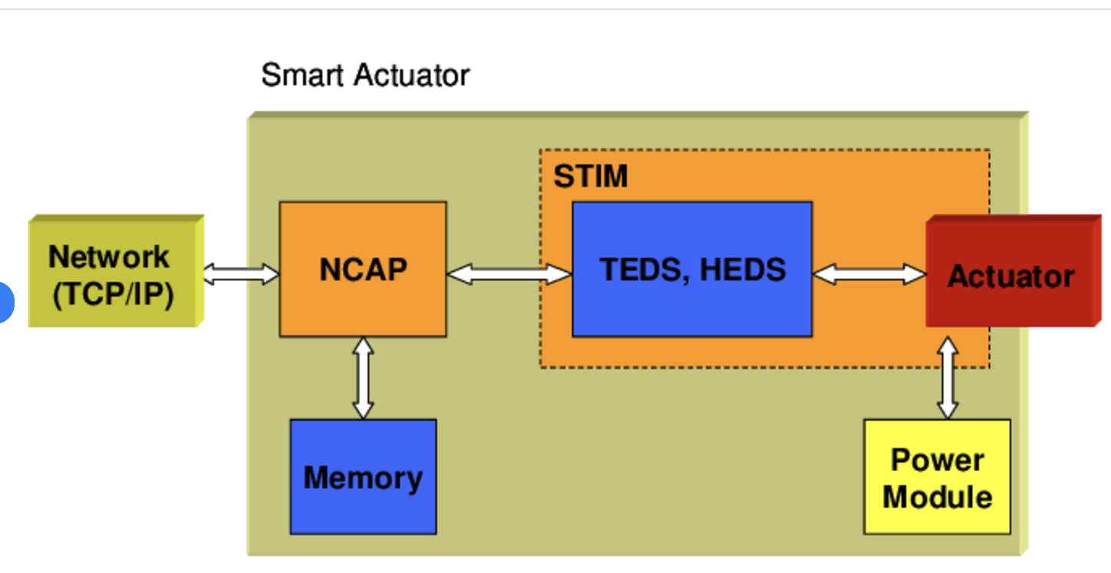

### History of Actuators in EVs

Actuators have evolved significantly over the years:

* **Early Beginnings:** Initially, actuators were simple mechanical devices.
* **Modern Developments:** With advancements in technology, actuators have become more sophisticated, incorporating electronics and software for better control and efficiency.

### Use Cases in EV Systems

Actuators are used in several applications within EV systems:

* **Steer-by-Wire:** Replaces traditional mechanical steering systems with electronic controls.
* **Brake-by-Wire:** Controls braking systems electronically without hydraulic pressure.
* **Shift-by-Wire:** Manages gear shifts electronically in automatic transmissions.
* **Suspension Control:** Adjusts the suspension system for better ride quality and handling.
* **Regenerative Braking:** Converts kinetic energy into electrical energy during braking.

### Types of Actuators in EVs

There are several types of actuators used in EVs:

* **Electric Motors:** Commonly used for propulsion and auxiliary systems.
* **Hydraulic Actuators:** Used in some braking and steering systems.
* **Pneumatic Actuators:** Less common but used in specific applications.
* **Piezoelectric Actuators:** Used for precise control in some advanced systems.

### Advantages of Actuators in EVs

* **Precision:** Provide accurate control over various systems.
* **Efficiency:** Help in optimizing energy use and improving fuel efficiency.
* **Reduced Weight:** Contribute to lighter vehicle designs.
* **Enhanced Safety:** Improve braking and steering response times.

### Disadvantages of Actuators in EVs

* **Complexity:** Increased complexity in vehicle systems.
* **Cost:** Higher initial costs compared to traditional mechanical systems.
* **Maintenance:** Require specialized knowledge for maintenance and repair.

### Features of Actuators in EVs

* **Compact Design:** Space-efficient for integration into EV systems.
* **High Durability:** Built to withstand harsh operating conditions.
* **Fast Response:** Quick reaction times for better control.
* **Integration with Electronics:** Seamless integration with vehicle electronics for advanced functionalities.

### ****System Architecture and Network Topology****

1. **System Architecture:**

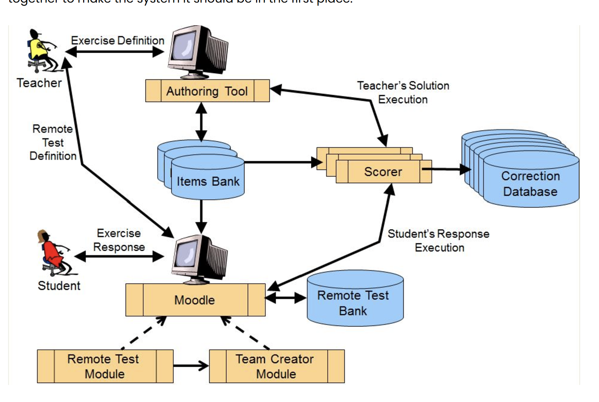

* + **Battery Management System (BMS):** Includes sensors (voltage, current, temperature) and an ECU to monitor and control the battery pack.
  + **Powertrain Control System:** Comprises the motor control unit (MCU), inverter, and associated sensors (position, speed, temperature) to manage motor functions.
  + **Thermal Management System:** Utilizes temperature sensors and an ECU to regulate cooling and heating for the battery and motor.
  + **Safety and Driver Assistance Systems:** Integrate sensors (cameras, radar, LiDAR, proximity) and an ADAS ECU for functions like adaptive cruise control and automatic emergency braking.
  + **Infotainment and Connectivity:** Involves an infotainment ECU and sensors (light, touch) for managing entertainment and navigation.
  + **Energy Management System:** Includes an ECU and energy flow sensors to optimize energy usage.
  + **Climate Control System:** Uses humidity and temperature sensors and an ECU to maintain cabin comfort.

**Network Topology**

Network topology refers to the arrangement of different elements (links, nodes, etc.) in a computer or vehicle network.

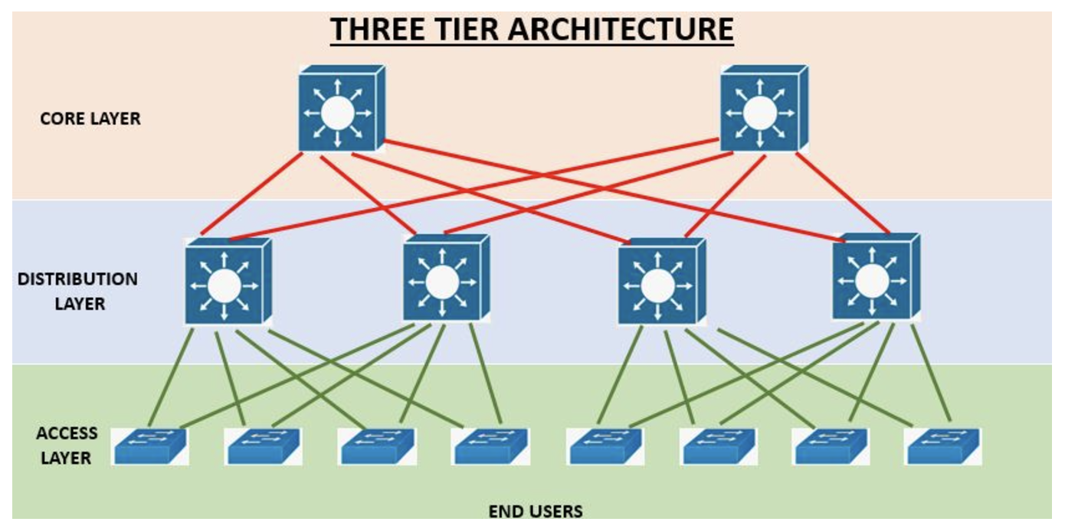

### ****Types of Network Topologies:****

1. **Bus Topology:**
   * **Description:** All devices share a single communication line.
   * **Advantages:** Simple to install, low cost.
   * **Disadvantages:** Limited cable length, difficult to troubleshoot.

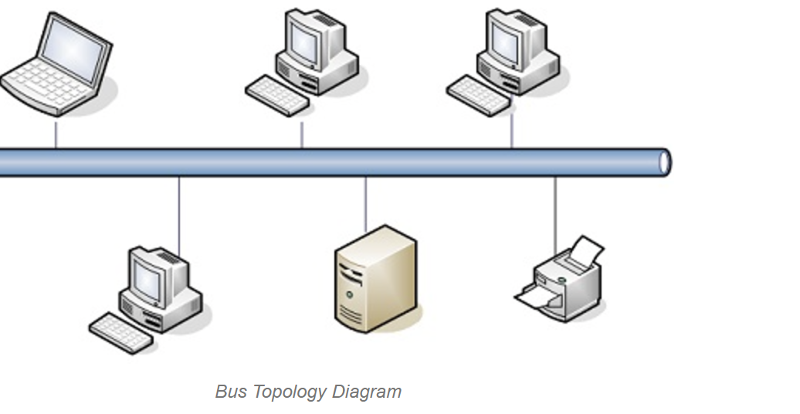

1. **Star Topology:**
   * **Description:** All devices are connected to a central hub.
   * **Advantages:** Easy to install and manage, scalable.
   * **Disadvantages:** If the central hub fails, the entire network goes down.



1. **Ring Topology:**
   * **Description:** Devices are connected in a circular fashion.
   * **Advantages:** Data flows in one direction, reducing the chance of packet collisions.
   * **Disadvantages:** A failure in any cable or device breaks the loop and can take down the entire network.

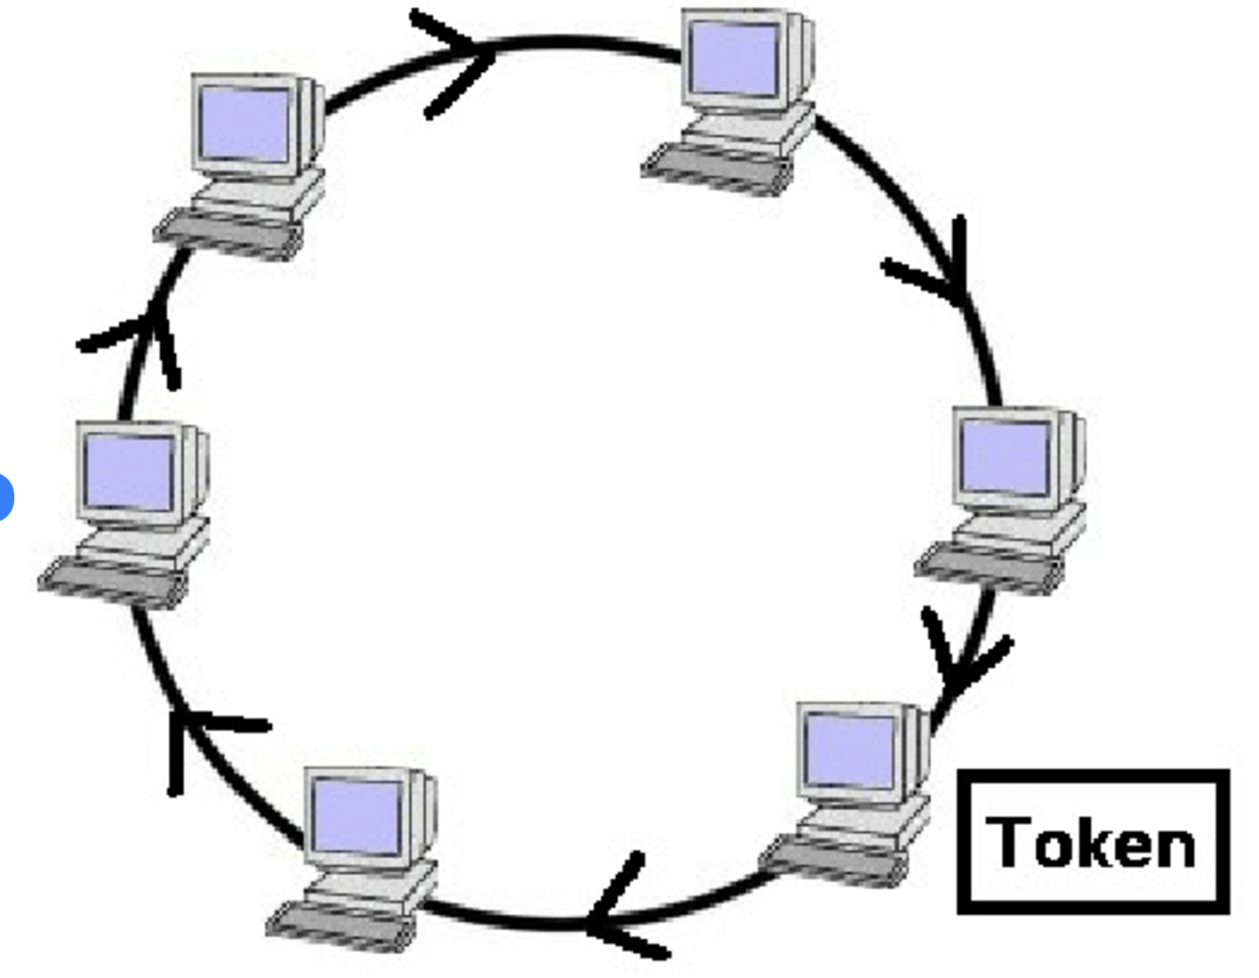

1. **Mesh Topology:**
   * **Description:** Every device is connected to every other device.
   * **Advantages:** High redundancy and reliability.
   * **Disadvantages:** Expensive to implement, complex to manage.



1. **Hybrid Topology:**
   * **Description:** Combines two or more different topologies.
   * **Advantages:** Flexible, scalable, and can be designed to meet specific requirements.
   * **Disadvantages:** Complex to design and manage.



### ****Applications in Electric Vehicles (EVs):****

* **CAN (Controller Area Network):** Commonly used for robust, real-time communication between ECUs.
* **LIN (Local Interconnect Network):** Used for lower-speed, cost-effective communication in body electronics.
* **FlexRay:** High-speed communication for time-critical applications like advanced driver assistance systems (ADAS).
* **Ethernet:** High bandwidth for infotainment and advanced communication features.

### ****Communication Protocols and Components****

**Communication Protocols**:

* + **Controller Area Network (CAN):** Facilitates robust, real-time communication between ECUs for critical systems like powertrain and safety.
  + **Local Interconnect Network (LIN):** A cost-effective protocol for non-critical communication, used in body electronics like lighting and seat adjustments.
  + **FlexRay:** A high-speed, fault-tolerant protocol for time-critical applications, such as ADAS and chassis control.
  + **Ethernet:** Provides high bandwidth for applications like infotainment and over-the-air updates.
  + **MOST (Media Oriented Systems Transport):** Specialized for multimedia and infotainment data transmission.

**Components:**

* + **ECUs (Electronic Control Units):** Serve as the brains of various subsystems, processing data and controlling actuators.
  + **Sensors:** Gather data from vehicle systems and environments, providing inputs to ECUs.
  + **Actuators:** Execute commands from ECUs to perform physical actions.
  + **Gateways:** Manage data flow between different communication networks.
  + **Communication Controllers:** Facilitate communication between ECUs and other network components.

### ****Wiring Harness and Connector Plan****

**Wiring Harness:**

* + **High-Voltage Cables:** Connect the battery to the motor and other powertrain components, ensuring safe power transfer.
  + **Low-Voltage Cables:** Connect sensors, controllers, and auxiliary systems like infotainment and lighting.
  + **Fuses and Relays:** Protect circuits from overcurrent and short circuits.
  + **Protective Sheathing:** Guards against physical and thermal damage.
  + **Terminal Blocks:** Simplify connections, making the harness more serviceable.

**Connector Plan**

* + **High-Voltage Connectors:** Ensure safe and efficient power transfer, designed to handle high currents and voltages.
  + **Low-Voltage Connectors:** Provide reliable connections for signal communication and auxiliary systems.
  + **Modular Connectors:** Allow for easier assembly and maintenance.
  + **EMI Shielding:** Prevents electromagnetic interference, ensuring signal integrity.
  + **Environmental Sealing:** Protects connectors from moisture, dust, and other environmental factors.

**Challenges and Considerations**

* **Complexity:** Integration and management of multiple systems and components.
* **Cost:** High-quality materials and advanced communication systems increase costs.
* **Maintenance:** Requires regular calibration and specialized knowledge.
* **Power Consumption:** Some systems consume significant power, affecting efficiency.
* **Environmental Vulnerability:** Components must be durable and resilient